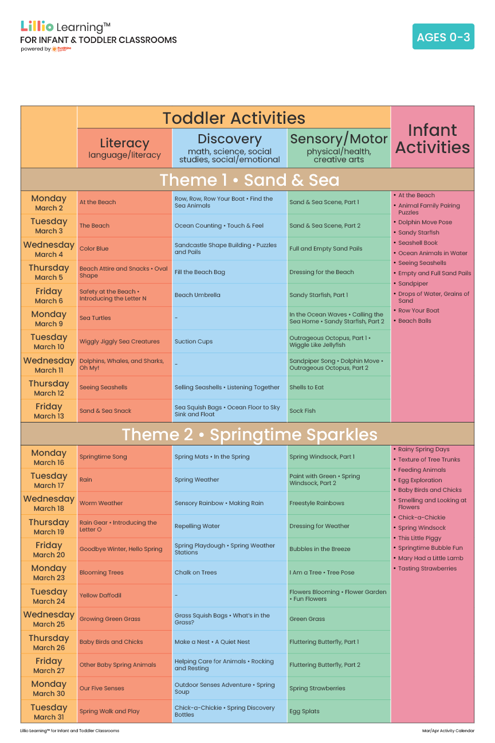
Add Your Name/Logo Here
March 2026
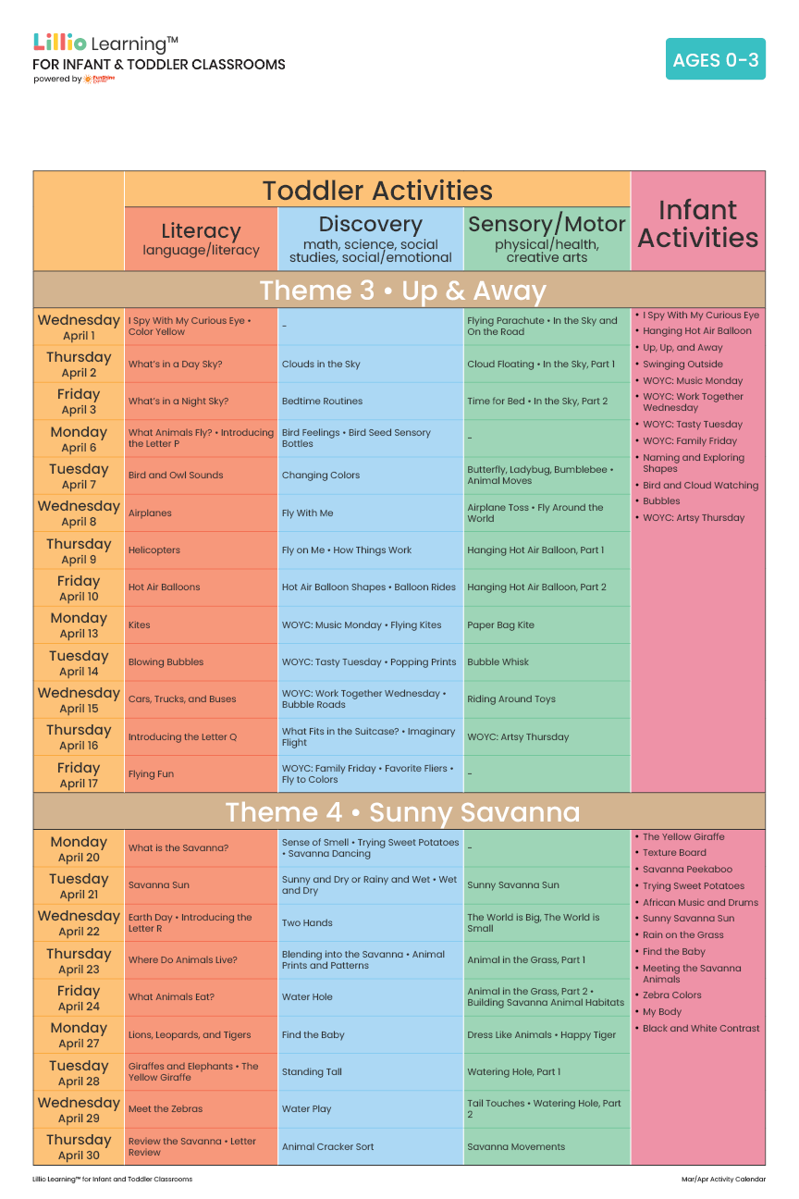
April 2026
Add Your Name/Logo Here

